Project Development Phase
Model Performance Test

Date | 08 October 2026
Team ID | 9100RootAccess
Project Name | Auto Ticket Classification using ServiceNow Flow Designer
Maximum Marks

Model Performance Testing:
Project team shall fill the following information in model performance testing template.
S.No. | Parameter | Screenshot / Values
 | Data Rendered | Ticket records are stored in the custom table Incident WorkFlow (u_incident_workflow) with Auto Number (Prefix INC, 5 digits). Sample records: INC00511 (Caller: Alfonso Griglen) and INC00512 (Caller: Sam Sorokin).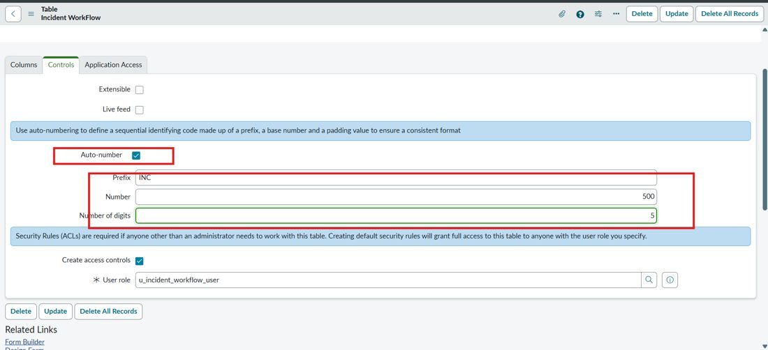  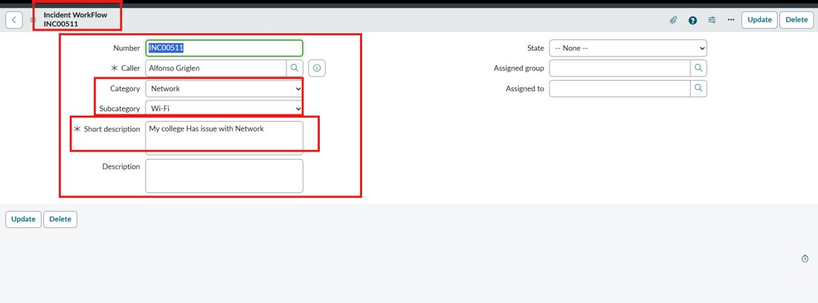
 | Data Preprocessing | Fields created with data types: Caller (Reference – sys_user), Category / Subcategory / State (Choice), Short description / Description (String), Assigned group (Reference – sys_user_group), Assigned to (Reference – sys_user). Subcategory is made dependent on Category with dependent values (network, hardware, access, performance).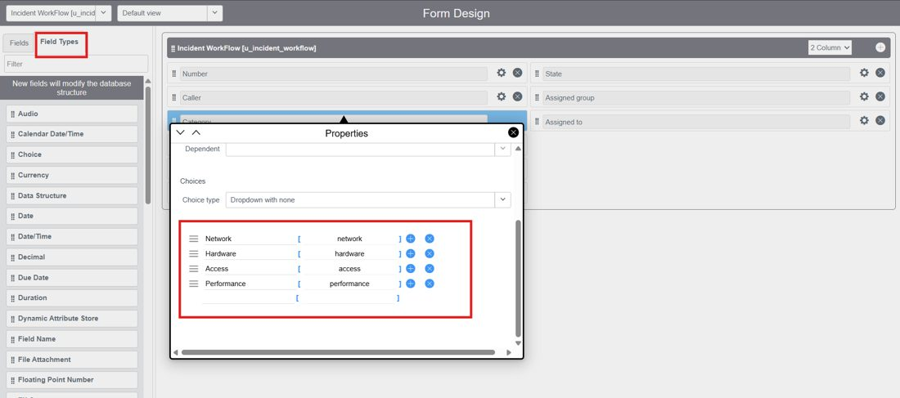  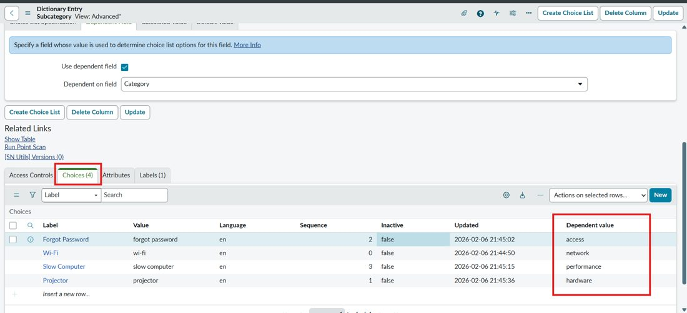
3. | Utilization of Data Filters | Flow trigger filter: Record Created on Incident WorkFlow where Category is empty, so only unclassified tickets are processed.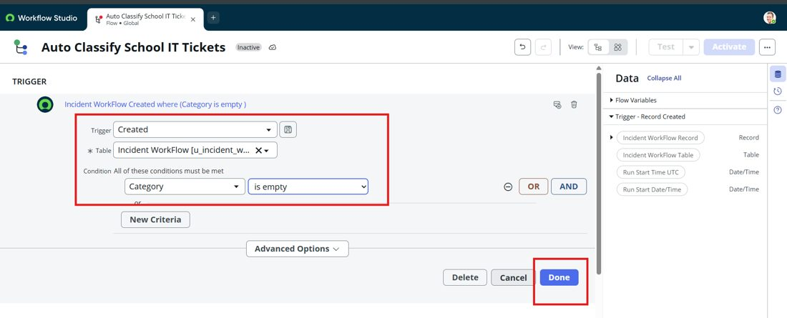
4. | Flow Conditions Used (no DAX / scripts) | If – Short description contains Wi-Fi OR Network  Else If – contains Projector  Else If – contains Forgot password  Else If – contains Slow computer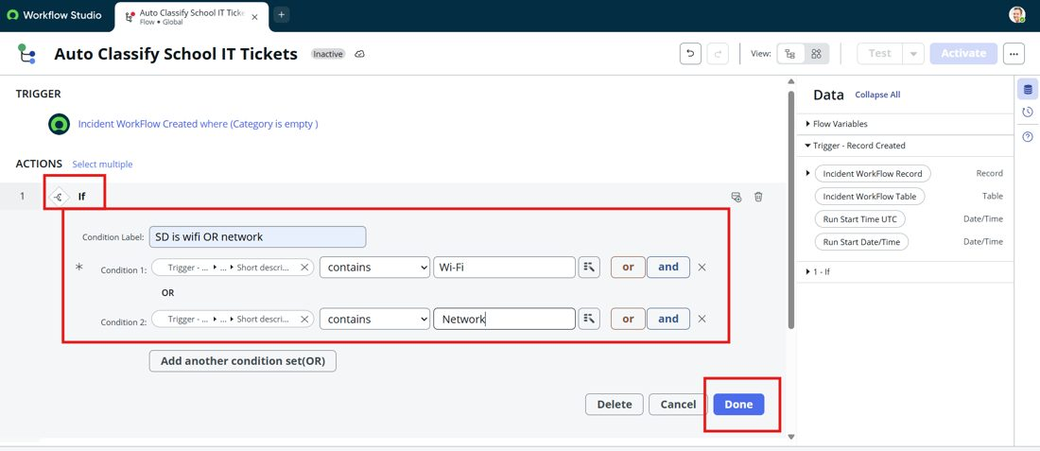  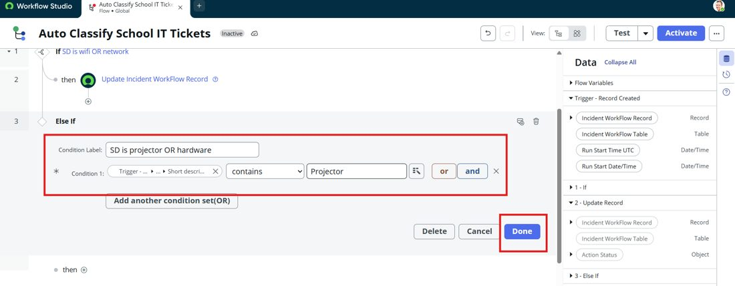
5. | Flow Design | No of Flow steps – 9 (1 If + 3 Else If conditions, 4 Update Record actions, 1 Send Email action) with 1 trigger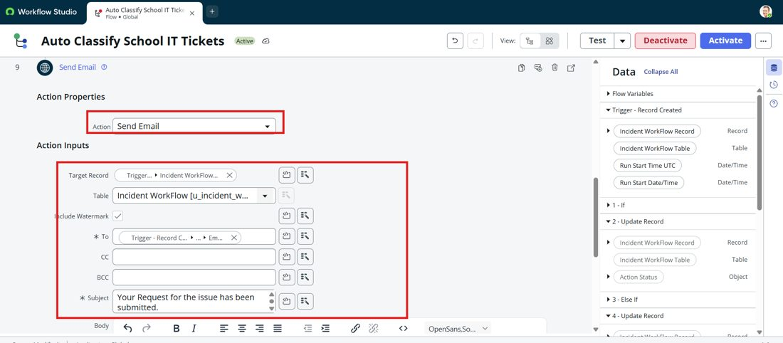
6 | Email Notification Report | No of Visualizations / Graphs – Not applicable (no dashboards). Notification: 1 email per ticket, subject “Your Request for the issue has been submitted.”, logged under System Logs → Emails.